**CP Club 365 Days Challenge**

**Programming language – PYTHON**

**Problem Statement**

<https://www.hackerrank.com/challenges/balanced-brackets/problem?isFullScreen=true>

**Your Code**:

# 0x91Day of 0x365Days challenge

# VEDANT BHARAD

# 16-1-2023

import math

import os

import random

import re

import sys

def isBalanced(s):

    # Write your code here

    arr = []

    for i in s:

        if i == '(':

            arr.append(1);

        elif i == ')':

            if len(arr) > 0 and arr[-1] == 1:

                arr.pop()

            else:

                return "NO"

        elif i == '[':

            arr.append(2)

        elif i == ']':

            if len(arr) > 0 and arr[-1] == 2:

                arr.pop()

            else:

                return "NO"

        if i == '{':

            arr.append(3)

        elif i == '}':

            if len(arr) > 0 and arr[-1] == 3:

                arr.pop()

            else:

                return "NO"

    if len(arr) == 0:

        return "YES"

    else:

        return "NO"

if __name__ == '__main__':

    fptr = open(os.environ['OUTPUT_PATH'], 'w')

    t = int(input().strip())

    for t_itr in range(t):

        s = input()

        result = isBalanced(s)

        fptr.write(result + '\n')

    fptr.close()

**Output (Screen Shot)**:

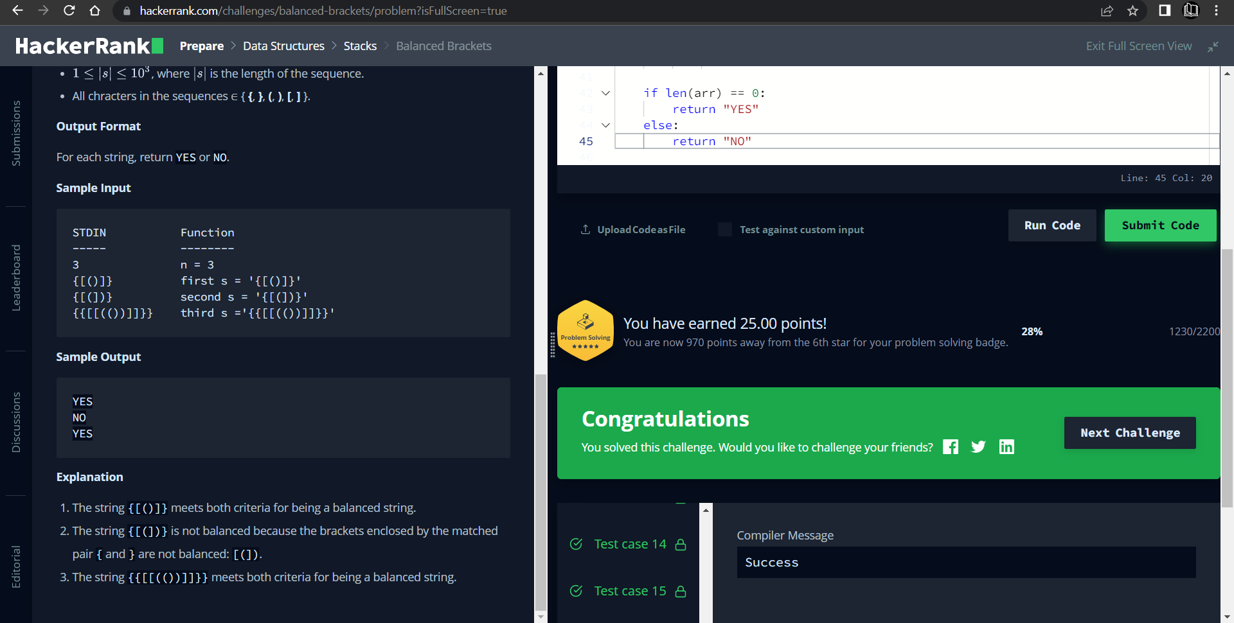

**Understanding about problem:**

* In this task I need to find brackets as a string is balanced or not if it is not then return NO else return YES.

Note: If you can't understand the problem, feel free to contact us and we'll help you. Please don't copy and paste from anywhere.

ALL THE BEST

Team CP Club